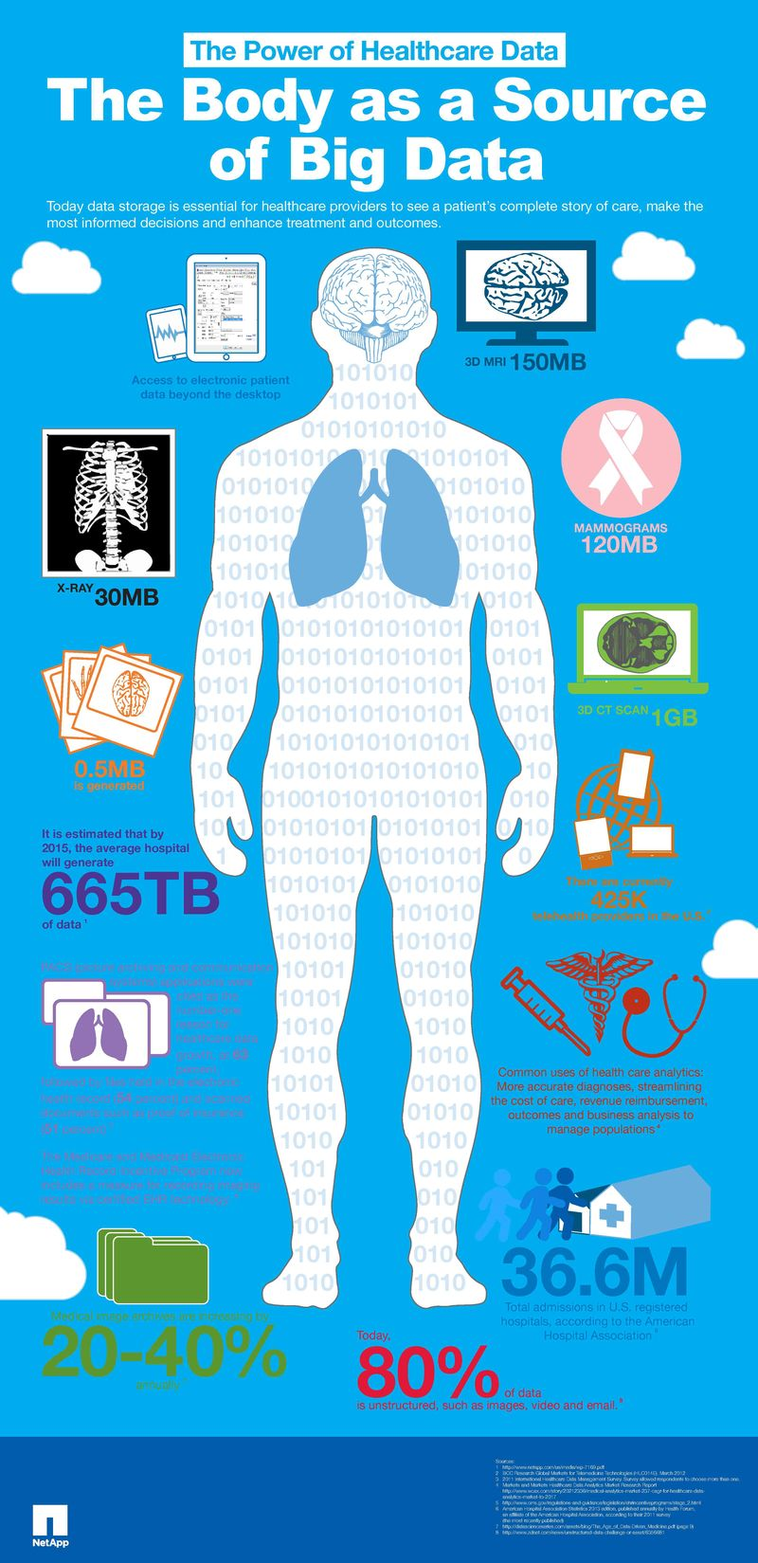

Big Data and Healthcare
  - Data, Methods and Infrastructures
Author 1, Author 2
UEC Big Data
[Teacher Name]
[Insert Date]

Table of Contents
Big Data and Healthcare 1
Introduction 1
Big Data in Healthcare 1
Methods Used to Process Big Data 1
Infrastructure to process Big Data 2
Conclusions 2

Big Data and Healthcare

Introduction
Set the context
Describe the problem
Identify sources of big data

Big Data in Healthcare
Types of data
Properties of data (size, velocity, variety, etc.)
Open Data
Linked Data (models, ontologies, etc.)

Methods Used to Process Big Data
Methods to collect data
Mining methods
Processing methods
Analytics
Privacy/Trust concerns

Infrastructures for Big Data Processing
Centralized / distributed
Cloud computing
Public / private processing

Conclusions
A summary of the situation
Bibliography
Last Name, F. (Date). Dolor Sit Amet. Lorem Ipsum, 1 - 10.
Last Name, F. (Date). Lorem Ipsum Dolor Sit Amet. City: Publisher.
Last Name, F. (Date). Lorem Ipsum Dolor Sit Amet. Duis sed elit ante, pp. 10-20.

